**Architecture**

Introduction

This is the C4-Architecture of the project “Webshop”. The goal of the project is to create web application which allows users to upload and purchase video games.

1.System Context

The Web Application “Webshop” will be used by customers to purchase products(video games). They can give back feedback on the products they have purchased in the form of reviews.

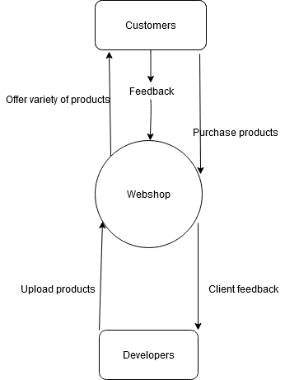

2. Containers

The “webshop” application consists of a Single page application Frontend, which uses JavaScript and ReactJS. It makes calls to the API(Java and spring boot) in the form of http requests and receives JavaScript Object Notation as a response. Information that needs to be remembered is then sent from the backend to the MySQL database.

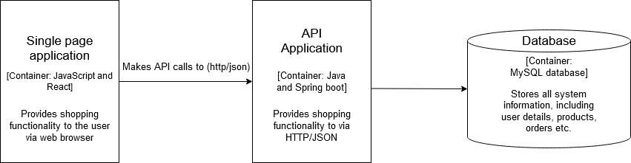

3.Components

The SPA communicates with the API controllers (Auth, Product and Picture) in order to retrieve the necessary information. The controllers perform CRUD operations in the database.

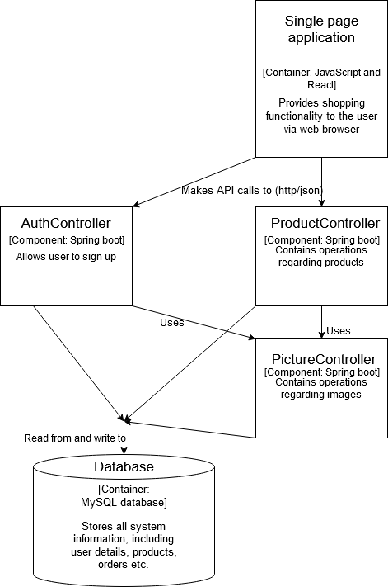

4.Controller (ProductResources)

Class ProductResources is the controller that handles operations regarding products. The end points allow creating a new product, updating it deleting it, as well as returning one or all of the existing products.

